**SQL server advanced 8:**

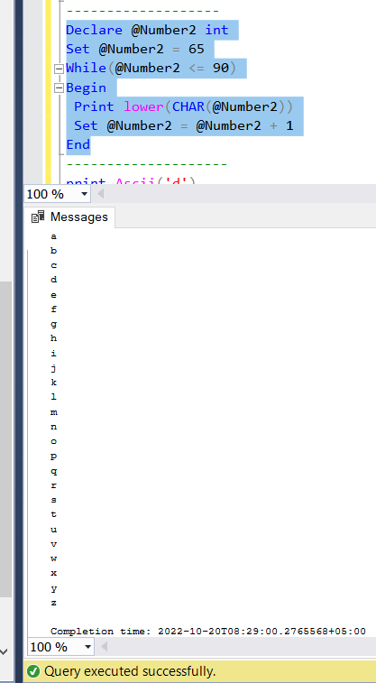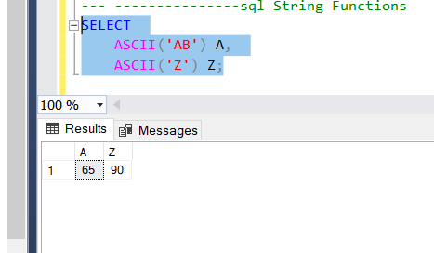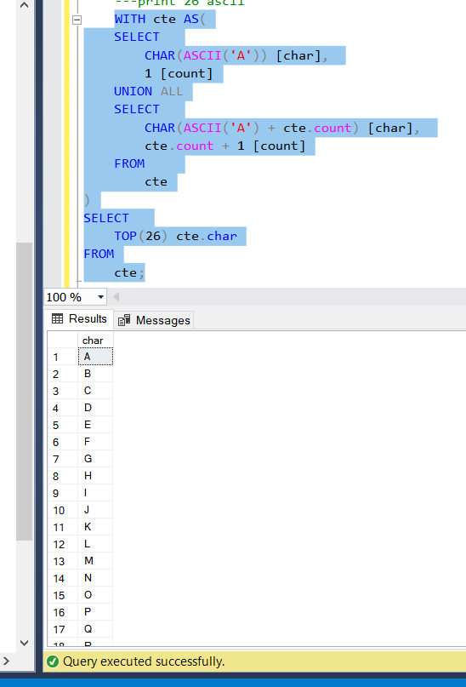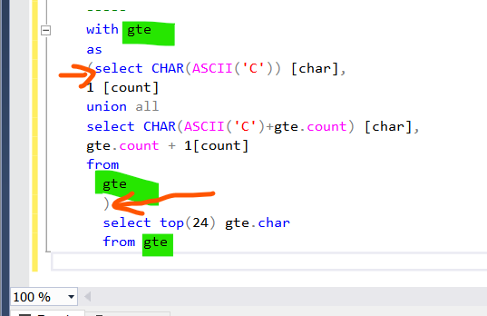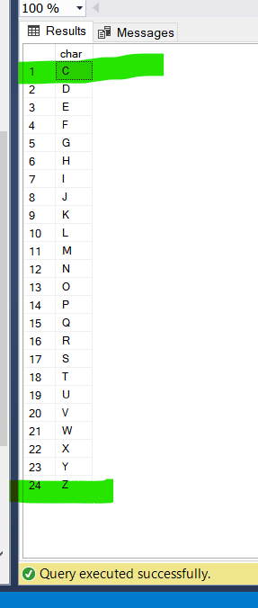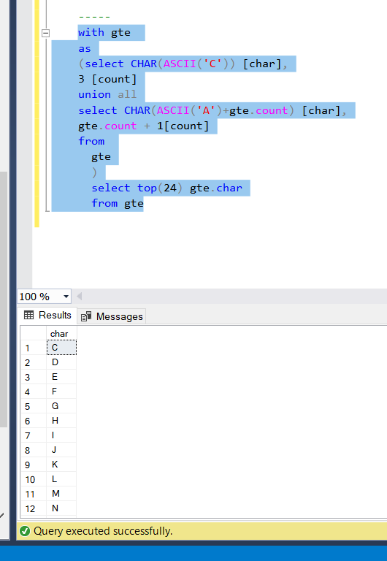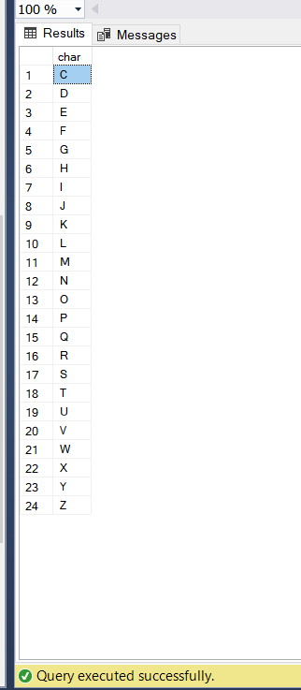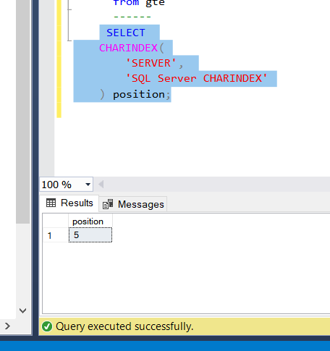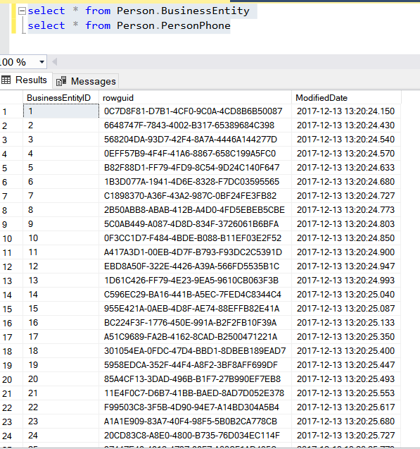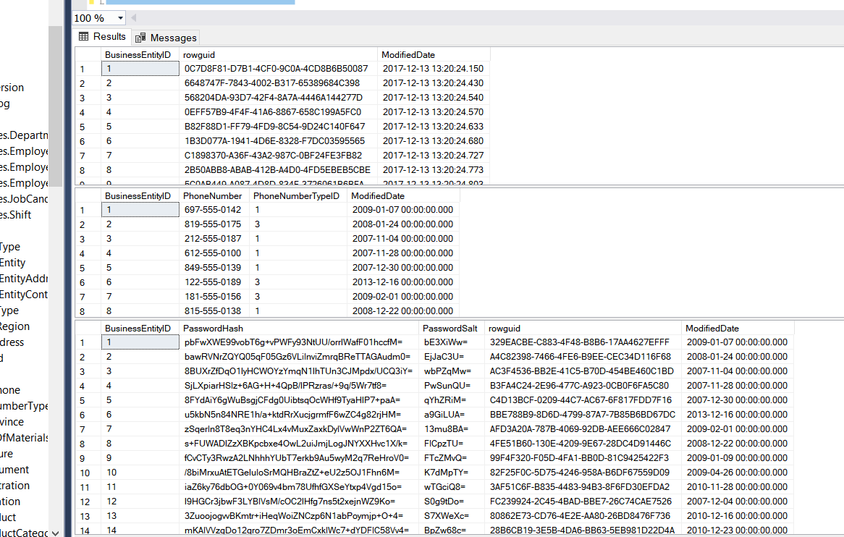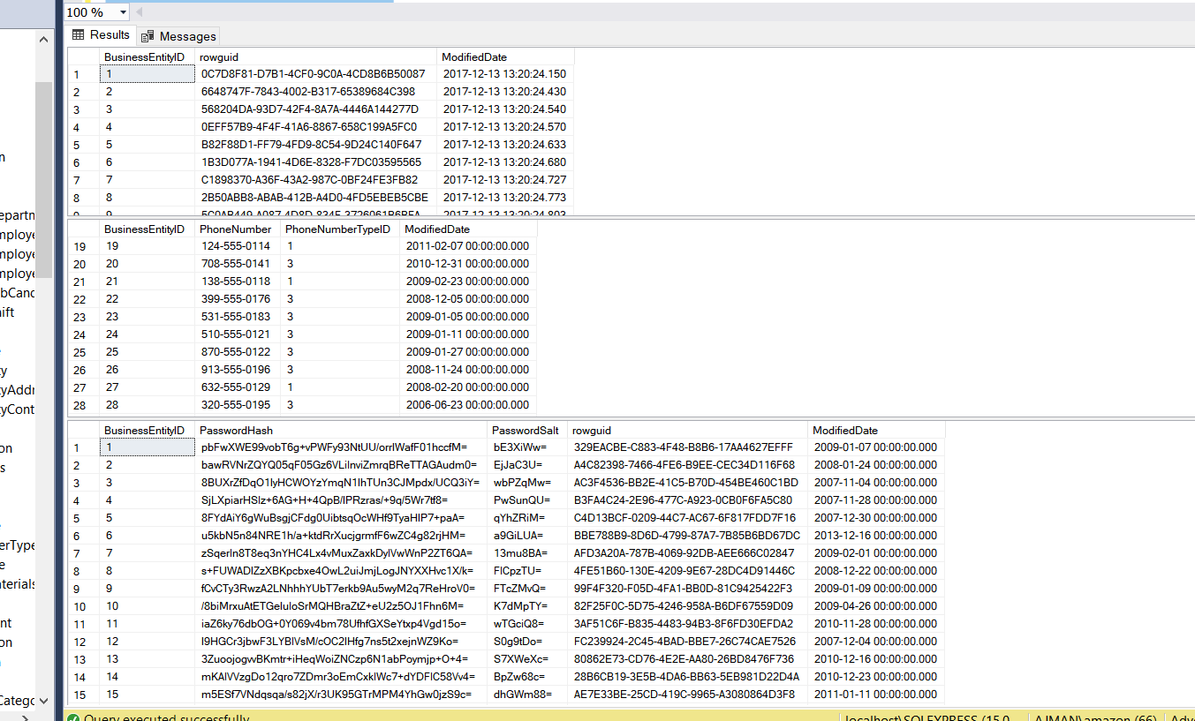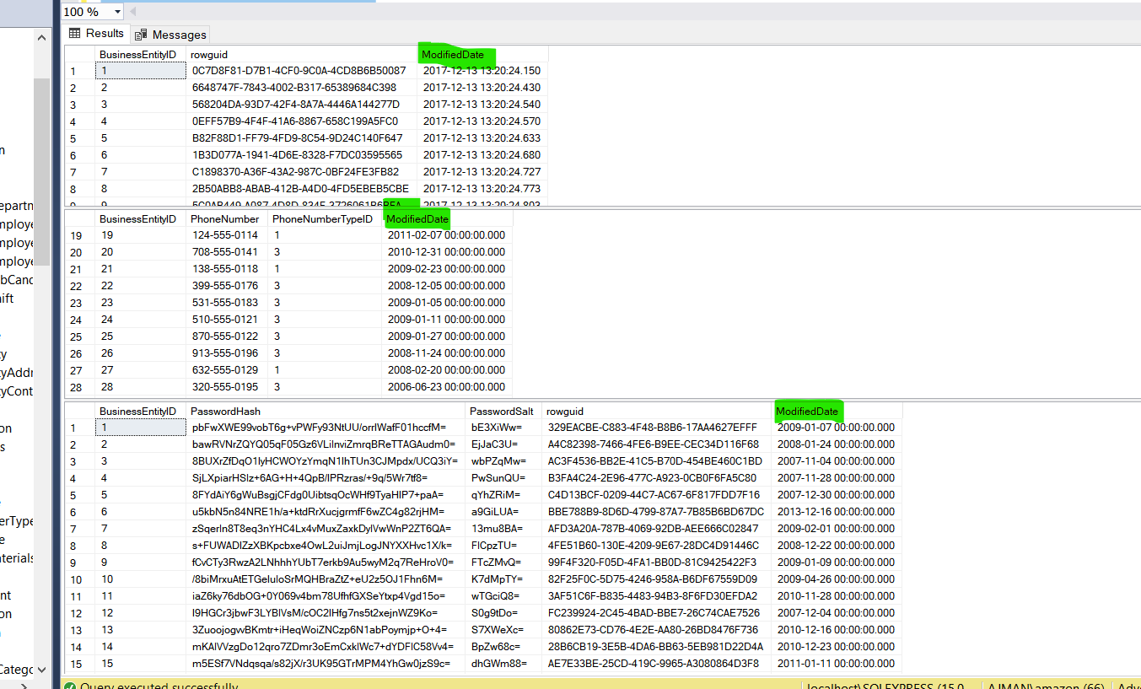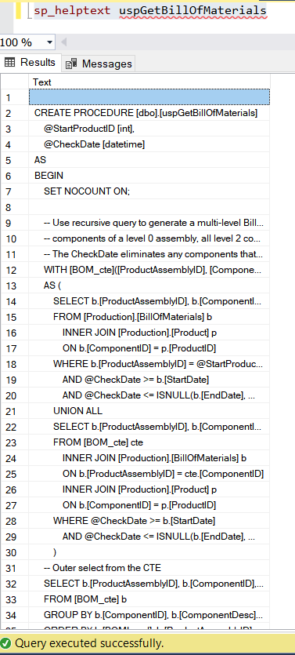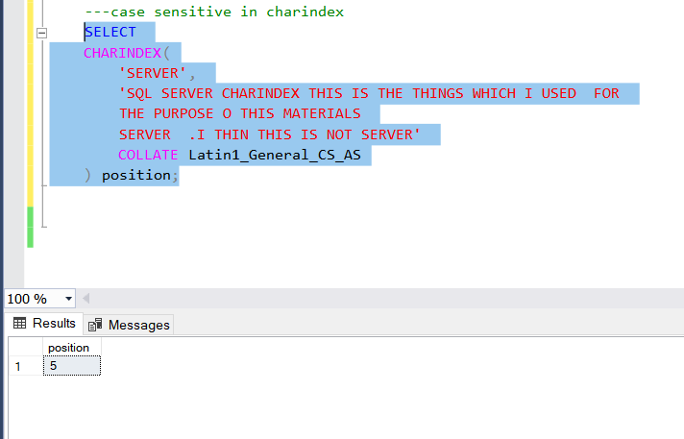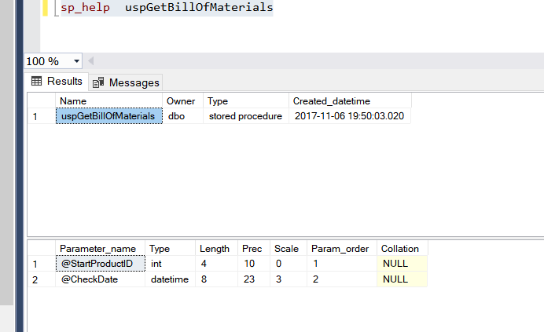

**Important links: charindex functions**

**<https://www.sqlservertutorial.net/sql-server-string-functions/sql-server-charindex-function/>**

### Using CHARINDEX() function to search for a nonexistent substring

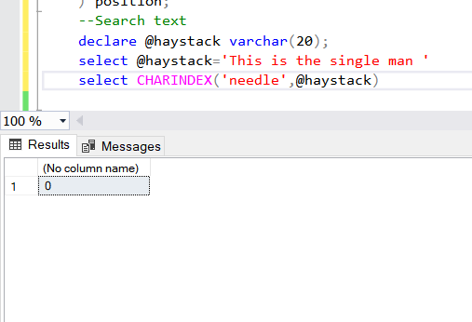

### Using CHARINDEX() function to searching from a specific position

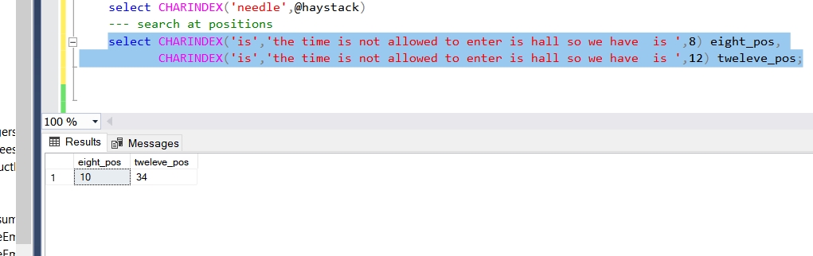

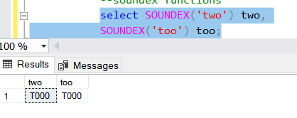

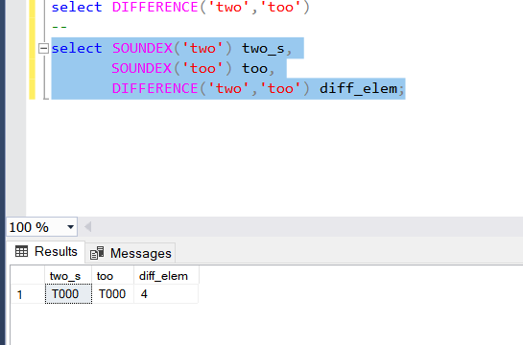

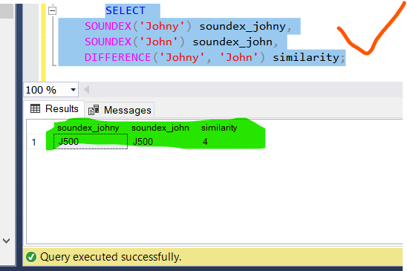

**Links:**

**<https://www.sqlservertutorial.net/sql-server-string-functions/sql-server-difference-function/>**

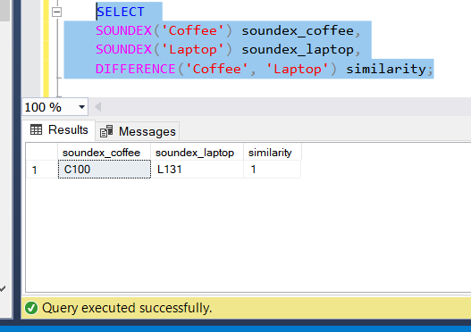

The CONCAT() takes two up to 255 input strings and joins them into one. It requires at least two input strings. If you pass one input string, the CONCAT() function will raise an error.

If you pass non-character string values, the CONCAT() function will implicitly convert those values into strings before concatenating.

The CONCAT() function also converts NULL into an empty string with the type [VARCHAR(1)](https://www.sqlservertutorial.net/sql-server-basics/sql-server-varchar/).

Note that to add a separator during the concatenation, you use the [CONCAT_WS()](https://www.sqlservertutorial.net/sql-server-string-functions/sql-server-concat_ws-function/) function.

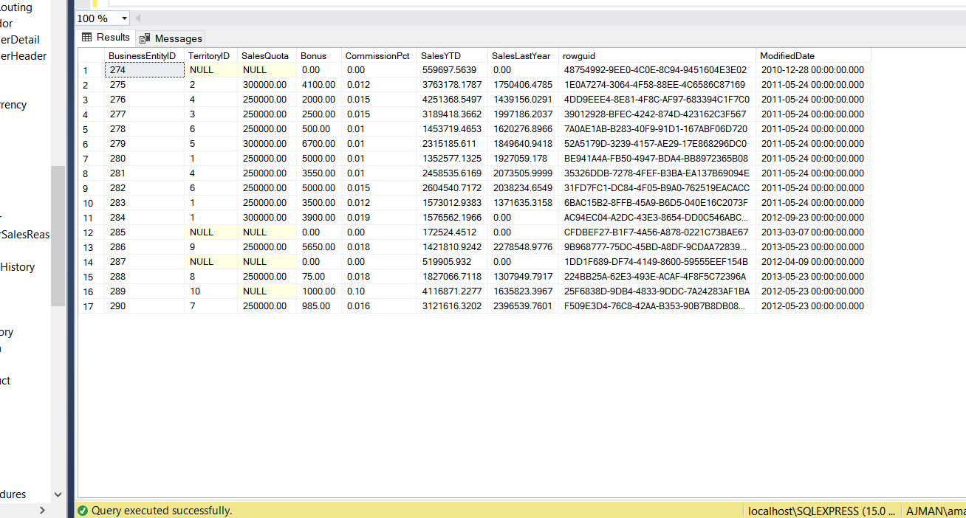

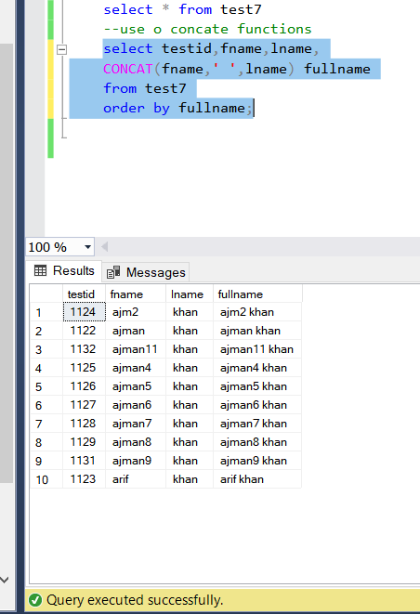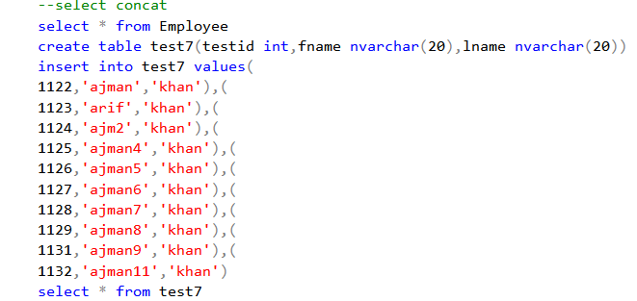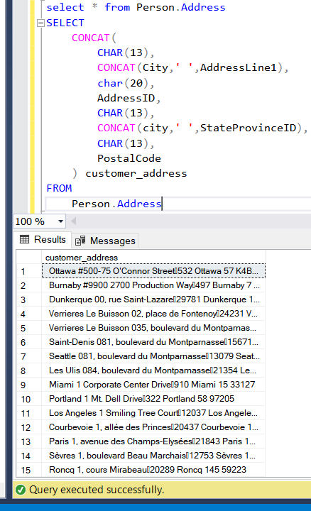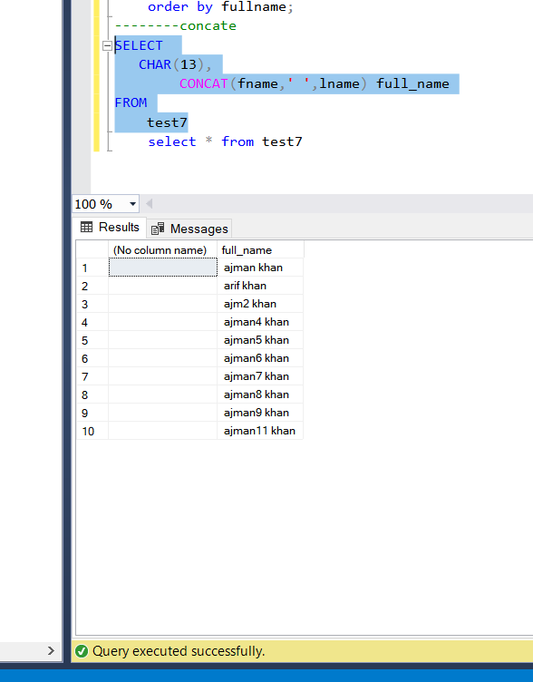

The SQL Server CONCAT_WS() function concatenates two or more strings into one string with a separator. CONCAT_WS() means concatenate with separator.

The following shows the syntax of the CONCAT_WS() function:

separator is a character-based expression that evaluates to any character of the type CHAR, NCHAR, VARCHAR, or NVARCHAR.

input_string1 to input_stringN are expressions of any type. The CONCAT_WS() function implicitly converts values of non-character type to character type before concatenation.

The CONCAT_WS() function joins the input strings into a single string. It separates those concatenated strings with the separator specified in the first argument.

Note that the CONCAT_WS() requires at least two input strings. It means that if pass zero or one input string argument, the function will raise an error.

The CONCAT_WS() function treats NULL as an empty string of type VARCHAR(1). It also does not add the separator between NULLs. Therefore, the CONCAT_WS() function can cleanly join strings that may have blank values.

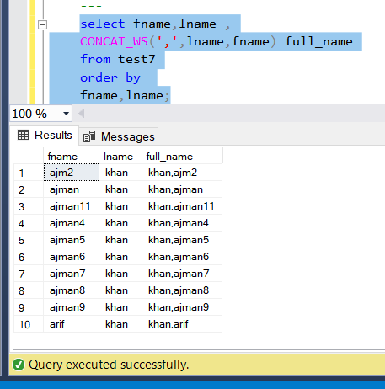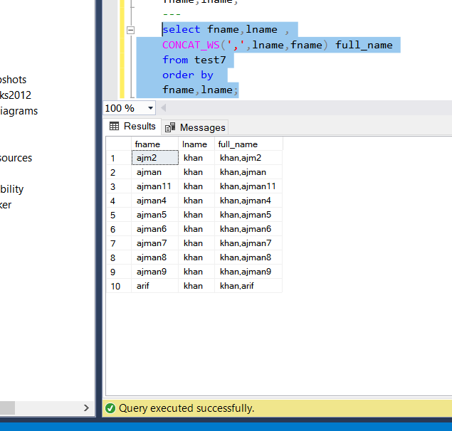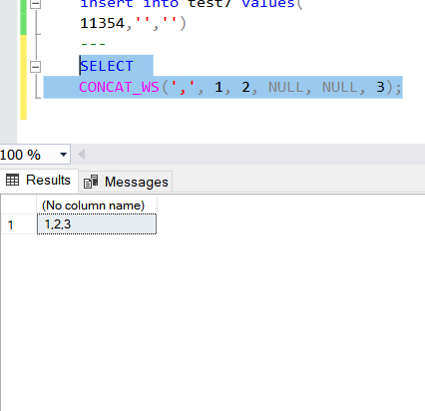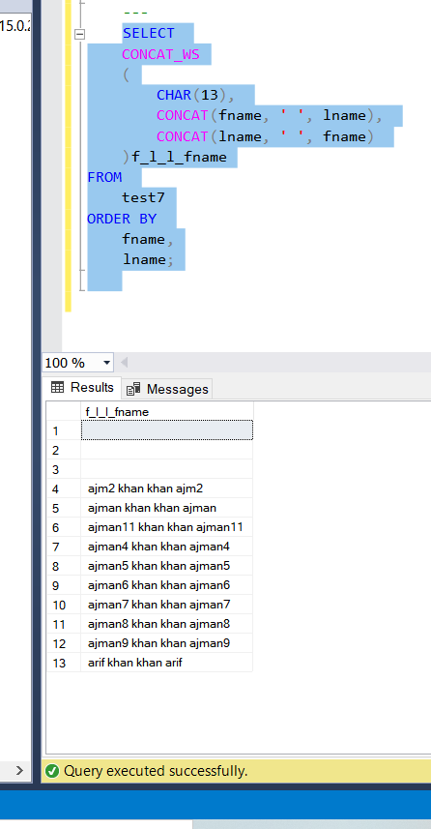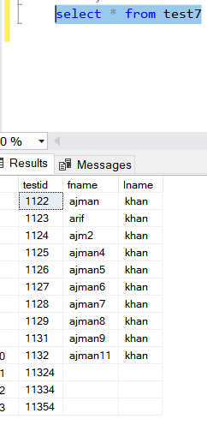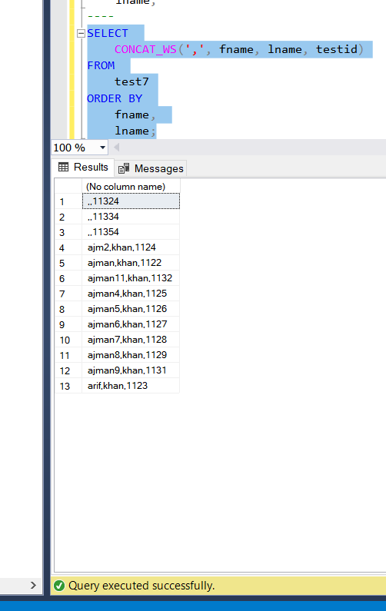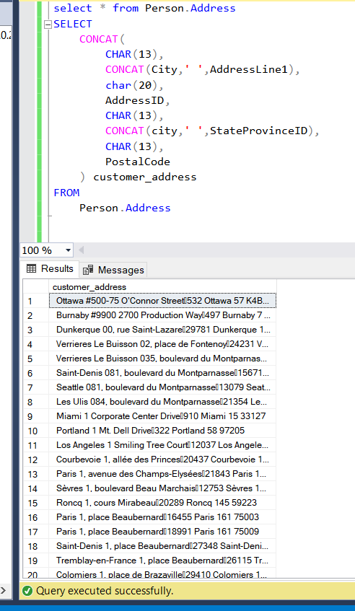

**Links:**

**<https://www.sqlservertutorial.net/sql-server-string-functions/sql-server-concat_ws-function/>**

**End**